# VRINDA STORE DATA ANALYSIS (**excel file)**

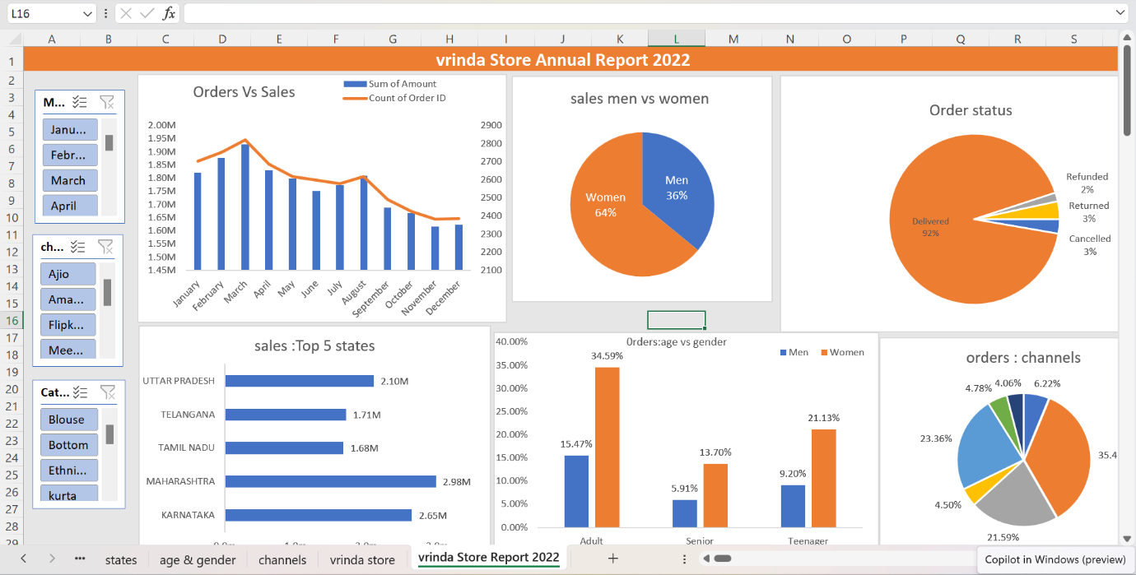

Title : Vrinda Store Annual Report - 2022

Tool used : Microsoft Excel

Objective :--

Vrinda store wants to create an annual sales report for 2022. So that ,Vrinda can understand their Customers and grow more sales in 2023

Approach :--

* This Dataset Contain Road Accident 2021-22 Data information.
* Understanding the dataset.
* Data Cleaning and Data Processing, Data Analysis Created some Formulas and Pivot Tables and charts & Graphs, interactive Dashboard.
* Creating business questions.
* Formulas : for age_group=if(E>=50,”Senior”,if(E>=30,”Adult”,”Teenager”)) ,for exctract month from date =TEXT(G>,”mmmm”)

Requirement :----

* Compare the sales and orders using single chart
* Which month got the highest sales and orders?
* Who purchased more -men or women in 2022?
* What are different order status in 2022?
* List top 10 states contributing to the sales?
* Relation between age and gender based on number of orders
* Which channel is contributing to maximum sales?
* Highest selling category?